Outcome
- The outcome of this procedure is to conduct a health check on the proposed SQL Server Virtual Machine during both the Pre-Migration and Post-Migration phases, transitioning from on-premises to Azure using Azure Migrate. This testing guarantees that:
  - Performance remains the same or better than the currently employed system post migration.
  - There are no errors in Windows or SQL Server Log post migration.
- This activity can take up to 2-3 hours to complete. The timing can be affected by:
  - Lack of access to Subscription/Resource Groups.
  - Missing required firewall rules.
  - SQL Server services failing to start after migration.
  - SQL IaaS Extension not installed for managing the Azure SQL Server VM.
  - Increased resource utilization (CPU, memory, and disk).
Prerequisites
The following are prerequisites for the successful completion of this procedure:
- Approved change within BMC Helix with appropriate notes attached to the change.
- Approved runsheet with date and timeline.
- Access to SQL Servers.
- Read access to Subscription (AppName Env), e.g., MIM Dev.
- Access to Database Resource Groups (AppName_DB) and backup_recovery_services_db.
- Ensure Application Landing Zone, Subscription, and Resource Group are created as per Standard Naming Convention - RM - CA16/413327.
- Ensure Recovery Service vault, Private Endpoint, Backup Policy (RM - CA16/413327) are in place under the backup_recovery_services_db Resource Group.
- Ensure Azure Key Vault and Private Endpoint (RM - CA16/413327) are in place under the Database Resource Group, e.g., MIM_DB.
- Ensure permission is granted to the Key Vault.
Actions
- Create the artefacts before and after migration and save the file as <ServerName_Artefacts.doc>.
- Pre-migration standalone SQL Server virtual machine validation test
- Ensure the nightly full backup completes successfully.
- Capture system information.
- Capture running and stopped services on the server.
- Capture IP details.
- Capture available disk details (I/O latency).
- Capture Windows Application and System logs from Event Viewer.
- Capture the SQL Server error log.
- Capture last job statuses.
- Capture SQL Server Configuration Manager (SQL Server Services status).
- Capture backup status (full and transaction log).
- Execute query to check active connections.
- Capture CPU, memory, and disk utilization.
- Ensure SQL Server instance connects with or without SQL port number from Tools Server and MSSQL Central Server.
- During cutover, stop SQL Server services (set to manual).
- Check server status in BMC Helix Discovery.
- List tables with row count.

- select * from sys.tables
select count(*) from table_name
- User Permission list.
- DB file Location .
sp_helfile
- SQL Agent Jobs details and Status
- SQL Configuration Details
sp_configure
- Server-level permission details
- Verify linked server connectivity
- Database server storage status
- Post-Migration Standalone SQL Server Virtual Machine Validation Test
- Log in to Azure Portal with the -a account.
- Navigate to Subscriptions and locate the subscription containing the application database for migration.
- Select the subscription name (e.g., EROLLPLUG DEV) and open the Resource group.
- Verify access to the Database Resource Groups (AppName_DB and backup_recovery_services_db).
- Ensure both the backup resource group (backup_recovery_services_db) and database resource group (AppName_DB, e.g., erollplug_db) are visible under Resource Groups.
- Open the AppName_DB resource group and confirm visibility of the virtual machine (migrated VM), SQL virtual machine, associated disks, network interface, and Key Vault.
- In Key Vault, check the private endpoint connection under networking.
- Verify RDP access to the Database Server from Tools Server and management Servers.
- Verify NAS Share access from the Database Server.
- Verify UNC path access to MSSQL Central and Management Servers from the Database Server.
- Verify UNC path access to the Database Server from MSSQL Central and Management Servers.
- Start SQL Server Services and set startup type to Automatic (Delayed Start).
- Replace the on-premise IP address with the new IP address in SQL Server Network Configuration (ipconfig).
- Disable SQL Server backup-related jobs; ensure Database Central and Database Maintenance Job remain enabled.
- Adjust the schedule for DBA_MaintenancePlan.Weekly Database Maintenance according to the application's window or runtime profile.
- Perform a SQL Server health check monitoring CPU, memory, and disk I/O.
- Verify instant file initialization is enabled in Local Security Policy.
- Confirm Windows Defender Firewall is disabled on the SQL Server VM.
- Check database server connectivity from tools and MSSQL Central.
- Ensure server status is updated in BMC Helix Discovery.
- List tables with row counts.
- select * from sys.tables
select count(*) from table_name
- User permissions list
- Database file location
sp_helfile
- SQL Agent job details and status
- SQL configuration details
sp_configure
- Server-level permission details
- Check linked server connectivity
- Database server storage status
- Run the following script for disk I/O latency
- SELECT
- [ReadLatency] =
- CASE WHEN [num_of_reads] = 0
- THEN 0 ELSE ([io_stall_read_ms] / [num_of_reads]) END,
- [WriteLatency] =
- CASE WHEN [num_of_writes] = 0
- THEN 0 ELSE ([io_stall_write_ms] / [num_of_writes]) END,
- [Latency] =
- CASE WHEN ([num_of_reads] = 0 AND [num_of_writes] = 0)
- THEN 0 ELSE ([io_stall] / ([num_of_reads] + [num_of_writes])) END,
- [Latency Desc] =
- CASE
- WHEN ([num_of_reads] = 0 AND [num_of_writes] = 0) THEN 'N/A'
- ELSE
- CASE WHEN ([io_stall] / ([num_of_reads] + [num_of_writes])) < 2 THEN 'Excellent'
- WHEN ([io_stall] / ([num_of_reads] + [num_of_writes])) < 6 THEN 'Very good'
- WHEN ([io_stall] / ([num_of_reads] + [num_of_writes])) < 11 THEN 'Good'
- WHEN ([io_stall] / ([num_of_reads] + [num_of_writes])) < 21 THEN 'Poor'
- WHEN ([io_stall] / ([num_of_reads] + [num_of_writes])) < 101 THEN 'Bad'
- WHEN ([io_stall] / ([num_of_reads] + [num_of_writes])) < 501 THEN 'Yikes!'
- ELSE 'YIKES!!'
- END
- END,
- [AvgBPerRead] =
- CASE WHEN [num_of_reads] = 0
- THEN 0 ELSE ([num_of_bytes_read] / [num_of_reads]) END,
- [AvgBPerWrite] =
- CASE WHEN [num_of_writes] = 0
- THEN 0 ELSE ([num_of_bytes_written] / [num_of_writes]) END,
- [AvgBPerTransfer] =
- CASE WHEN ([num_of_reads] = 0 AND [num_of_writes] = 0)
- THEN 0 ELSE
- (([num_of_bytes_read] + [num_of_bytes_written]) /
- ([num_of_reads] + [num_of_writes])) END,
- LEFT ([mf].[physical_name], 2) AS [Drive],
- DB_NAME ([vfs].[database_id]) AS [DB],
- [mf].[physical_name]
- FROM
- sys.dm_io_virtual_file_stats (NULL,NULL) AS [vfs]
- JOIN sys.master_files AS [mf]
- ON [vfs].[database_id] = [mf].[database_id]
- AND [vfs].[file_id] = [mf].[file_id]
- -- WHERE [vfs].[file_id] = 2 -- log files
- ORDER BY [Latency] DESC
- -- ORDER BY [ReadLatency] DESC
- -- ORDER BY [WriteLatency] DESC;
GO
- In the Resource Group backup_recovery_services_db, go to Settings and select Networking. Under Private access, confirm the private endpoint exists and follows the naming convention.
- In the Recovery Services Vault Properties, review the Security settings:
  - Under Immutable Vault settings, verify:
  - Enable vault immutability: Set to Enable
  - Lock immutability for this vault: Set to Unlocked
- Under Manage, select Backup policies. If policies were not created with Terraform, configure these three policies:
  - SQLServerBackupPolicy1: Full backup weekly, transactional backup hourly
  - SQLServerBackupPolicy2: Full backup daily, transactional backup hourly, monthly
  - SQLServerBackupPolicy3: Full backup weekly, differential backup daily, transactional backup hourly, monthly
- Post Migration Tasks (Applicable once the above test is successful)
- Create the SQLInsight login to set up monitoring on Azure Monitor Insight.
- Set the recovery model of <DBA_Maintenance> and all user databases to Full Recovery Model.
- Configure database backup on Recovery Service Vault.
- Initiate full and transaction log backups of <DBA_Maintenance>.
- Perform restore test of <DBA_Maintenance> using Recovery Service Vault.
- Set the recovery model of <DBA_Maintenance> to Simple.
- Drop the restore test database from SQL Server instance.
- Run SQL best practice assessment for Azure SQL Server VM from M849PRD1.
- Configure TDE.
- Configure SSL certificate.
- Configure an Azure SQL Server Database Backup
- Execute this script on MSSQL_Central to update the datacenter location

- * Update the Datacenter Location
- --Execute the following script on MSSQL_Central (M903PRD1)
- {{{
- --MSSQL_Central (M903PRD1)
- --Under the Virtual Machine Overview Page - > Availability + scaling - > Availability Zone
- -- Verify the Availability Zone
- --If Availability Zone - 1, update the Datacenter with ‘AUSTRALIA EAST AZ1'
--If Availability Zone - 2, update the Datacenter with ‘AUSTRALIA EAST AZ2'
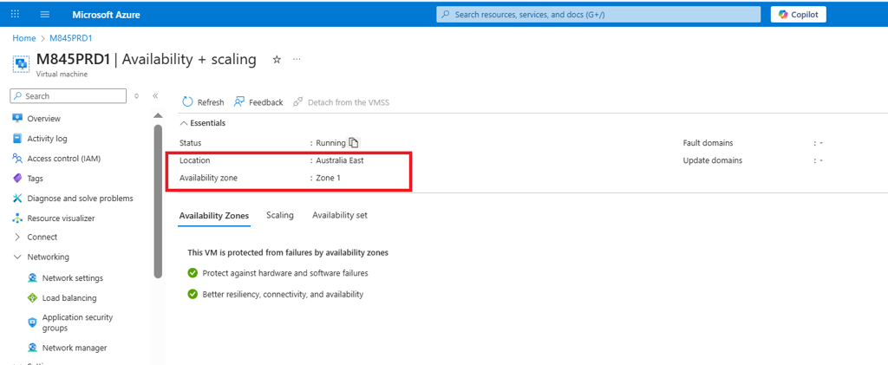
use [Database_Central]
go
select * from bcc.mssqL_datacenter_details where Computer_Name = '<Computer_Name>'
Go
update bcc.mssql_datacenter_details
set Datacenter = 'AUSTRALIA EAST AZ1 / AUSTRALIA EAST AZ2'
where Computer_Name = '<Computer_Name>' --New Migrated Server
go
- Ensure you execute the query on the correct SQL Server instance:
- SELECT SERVERPROPERTY ('SERVERNAME') AS [INSTANCE_NAME]
GO
- Update the cluster name of the migrated virtual machine on the designated SQL Server instance
- use [DBA_Maintenance]
- go
- select * from DBA_Maintenance.bcc.global_constants where name ='CLUSTER NAME'
- go
- update DBA_Maintenance.bcc.global_constants
- set value1 = '<CLUSTER_NAME>' --AZURE IAAS
- where name = 'CLUSTER NAME'
go
- Update the Backup Schedule on designated SQL Server Instance.
- Execute the following script to verify the current schedule to designated SQL Server Instance
- -- Policy 1 - SQLServerBackupPolicy1-Full-Weekly-Trans-Hourly - Applicable for Non Production Source
- -- Policy 2 - SQLServerBackupPolicy2-Full-Daily-Trans-Hourly-Monthly - Applicable for Production Source
- -- Policy 3 - SQLServerBackupPolicy3-Full-Weekly-Diff-Daily-Trans-Hourly-Monthly - Applicable for Production Source
- --First Verify the current Schedule by executing the following query(Schedule -> On Prem -> DAILY, Azure IAAS
- SELECT [name]
- ,type
- ,[value1]
- FROM [DBA_Maintenance].[bcc].[global_constants]
WHERE NAME = 'BACKUP SCHEDULE'
- If no value returns you need to insert the value based on the Policy / Location.
- INSERT INTO [bcc].[global_constants]
- ([name]
- ,[type]
- ,[value1]
- )
- VALUES ('BACKUP SCHEDULE','nvarchar','DAILY')
GO
- If value returns, update the Schedule based on Policy /Location.
- UPDATE [DBA_Maintenance].[bcc].[global_constants]
- SET value1 = 'WEEKLY' -- WEEKLY / DAILY
WHERE NAME = 'BACKUP SCHEDULE'
- -- Please verify the latest version of Stored Procedure - [DBA_Maintenance]- > [bcc].[usp_manage_sql_server_central_details] - version 1.12.
- You will find the latest version on - \\nas-ds\os-is-sd-data-software$\SQL Server\DBA Maintenance_2024\usp_manage_sql_server_central_details_v1.12.sql or M915PRD1 - > E:\Stage\DBA_Maintenance\usp_manage_sql_server_central_details_v1.12.sql
- 1. Alter the latest version of Stored Procedure - [bcc].[usp_manage_sql_server_central_details]
- 2. Run the <DBA_MaintenancePlan.Update SQL Server Central> Job on SQL Server Instance.
- --Verify the Schedule details on Database_central.
- --Replace a.Server_Name = '<Instance_Name>' -- e.g.'M845UAT1\SEGP01'
- SELECT a.Server_Name,b.Database_name,b.Last_Modified_Date,b.Backup_Schedule,b.Last_database_Backup_date,
- b.Last_Database_Diff_Backup_Date,b.Last_Database_Log_backup_Date
- FROM MSSQL_CENTRAL.Database_Central.bcc.mssql_server a, MSSQL_CENTRAL.Database_Central.bcc.MSSQL_Database b
WHERE a.server_id = b.server_id and a.Server_Name = '<Instance_Name>' and b.Decommission_Date IS NULL
- Update the confluence to reflect the new environment and any changes in configurations or procedures.
- Pre-Migration Clustered SQL Server Virtual Machine Validation Test
- Ensure all migration steps given above for the standalone SQL Server VM are completed. Additionally, follow these steps for Clustered SQL Server VM :
- Open the AlwaysOn dashboard and check that the Availability Group state is healthy.
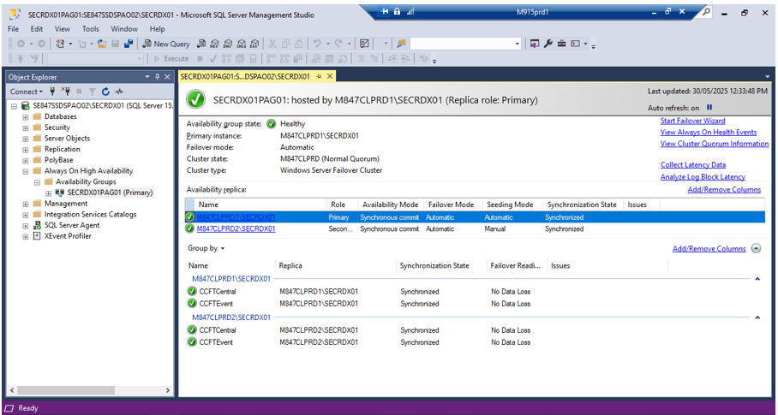
- Open Failover Cluster Manager and ensure that the cluster core resources are online.
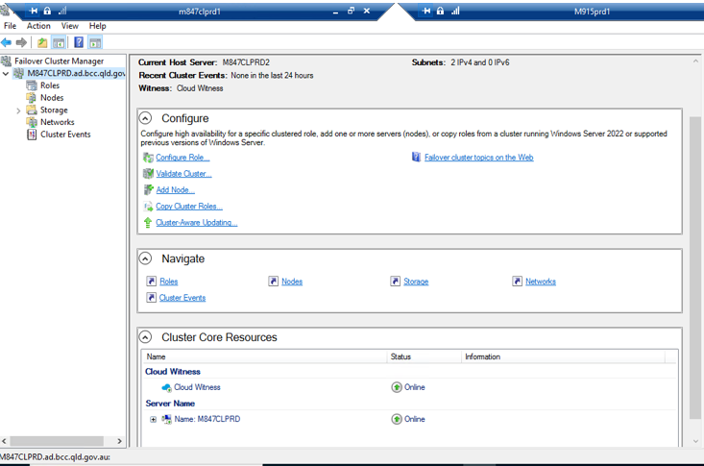
- In Failover Cluster Manager, open Roles and verify that their status is Running.
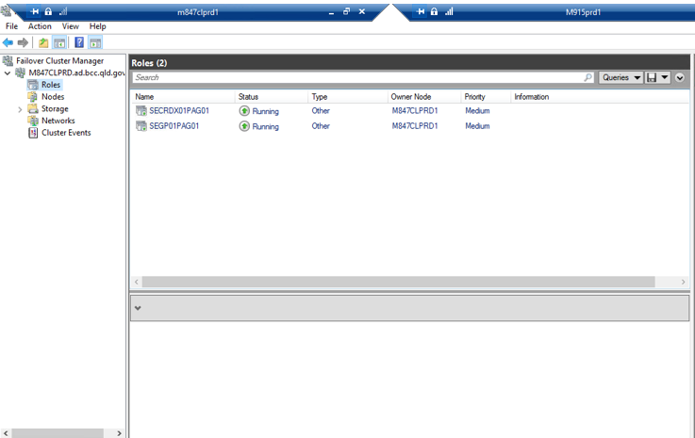
- In Failover Cluster Manager, open Node and verify that their status is up.
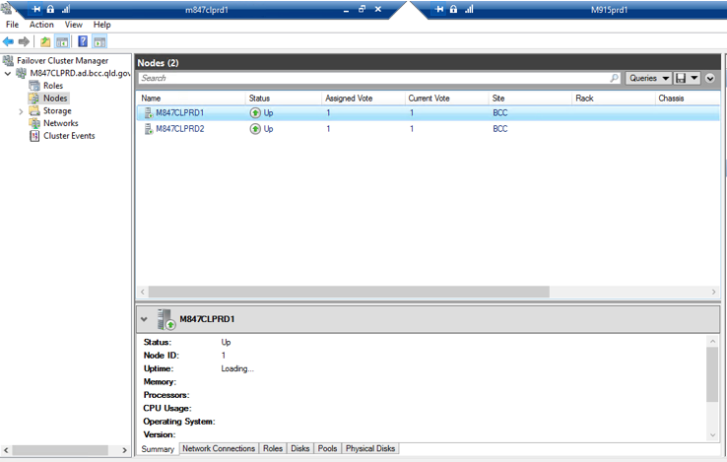
- In Failover Cluster Manager, open Network and verify that their status is up.
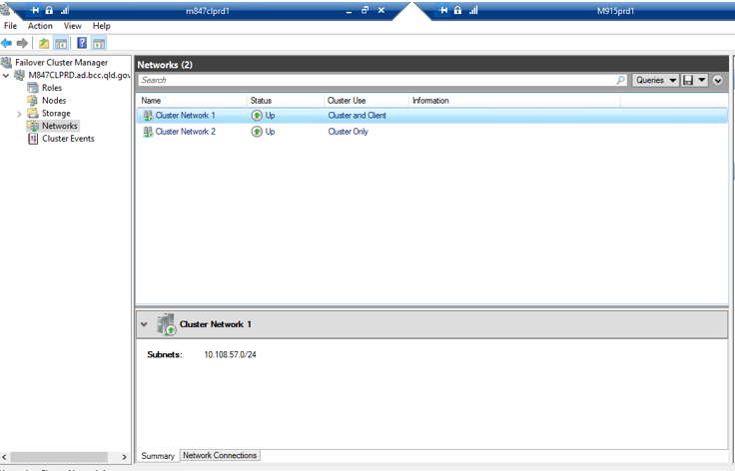
- In Failover Cluster Manager, open the Cluster event and check for any errors.
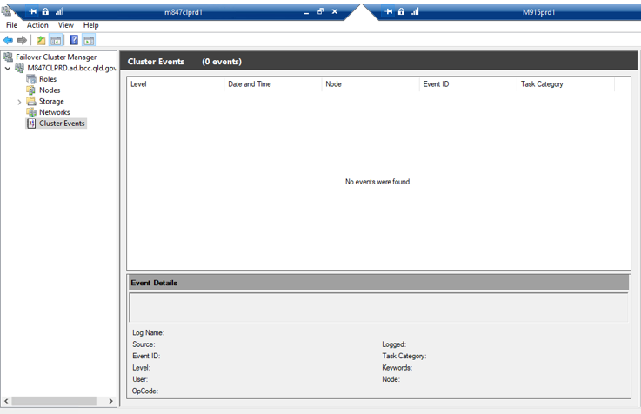
- Post-Migration Clustered SQL Server Virtual Machine Validation Test
- Ensure all post migration steps given above for the standalone SQL Server VM are completed. Additionally, follow these steps for Clustered SQL Server VM :
- Open the AlwaysOn dashboard and check that the Availability Group state is healthy.

- Open Failover Cluster Manager and ensure that the cluster core resources are online.

- In Failover Cluster Manager, open Roles and verify that their status is Running.

- In Failover Cluster Manager, open Node and verify that their status is up.

- In Failover Cluster Manager, open Network and verify that their status is up.

- In Failover Cluster Manager, open the Cluster event and check for any errors.


Confirmation

